**Helm Chart**

1. It is a package manager for Kubernetes cluster.
2. We can install from the below ones

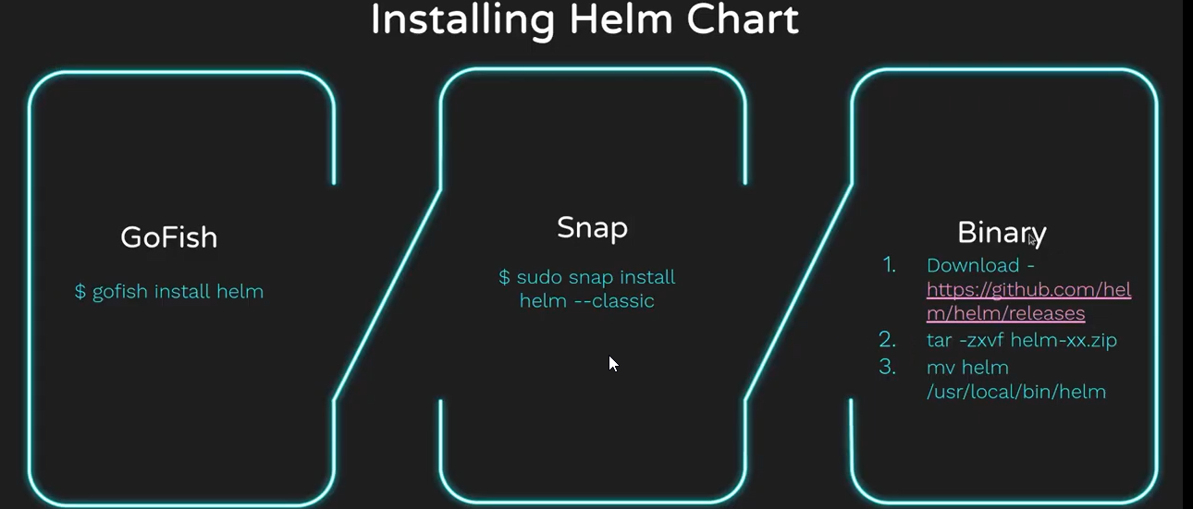

We can download from the below ones

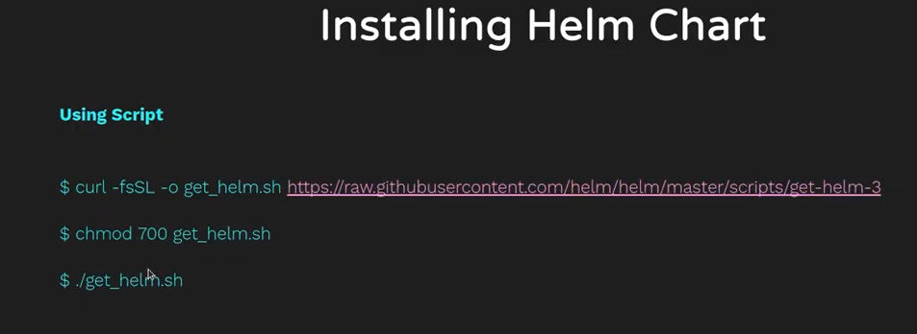

Helm file structure: chart.yaml, values.yaml and templates

If you’re using yaml the first command your using is helm create demochart once you execute the command we will see the below directory created with demo chart (predefined values)

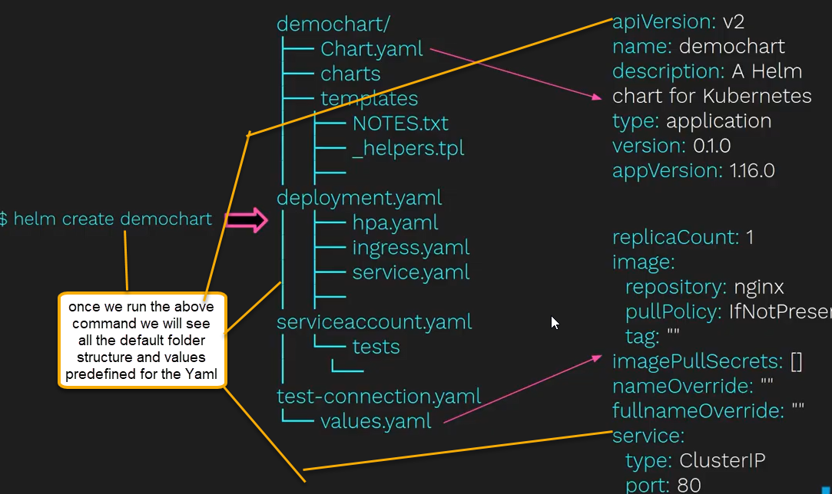

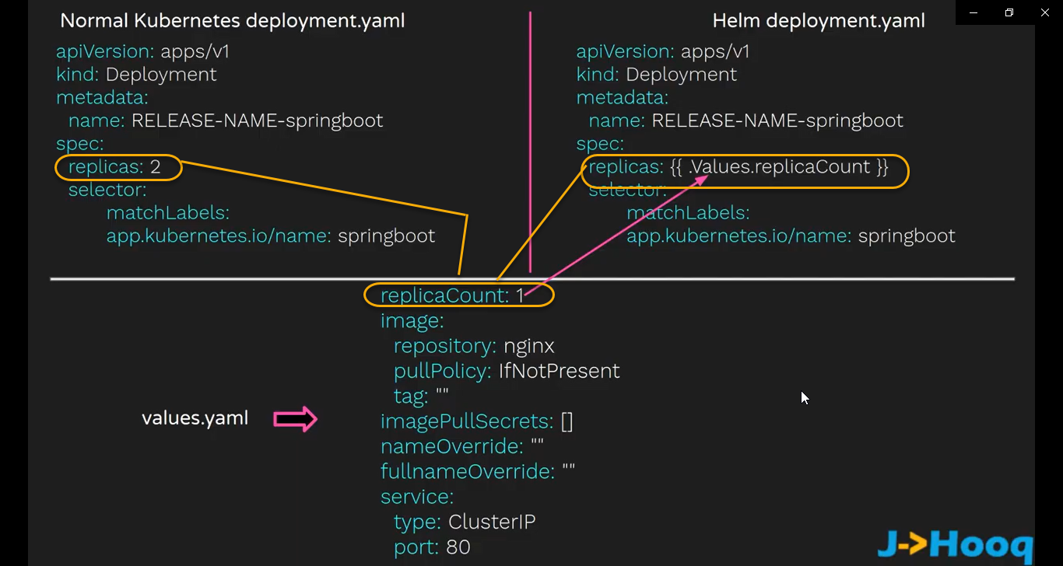

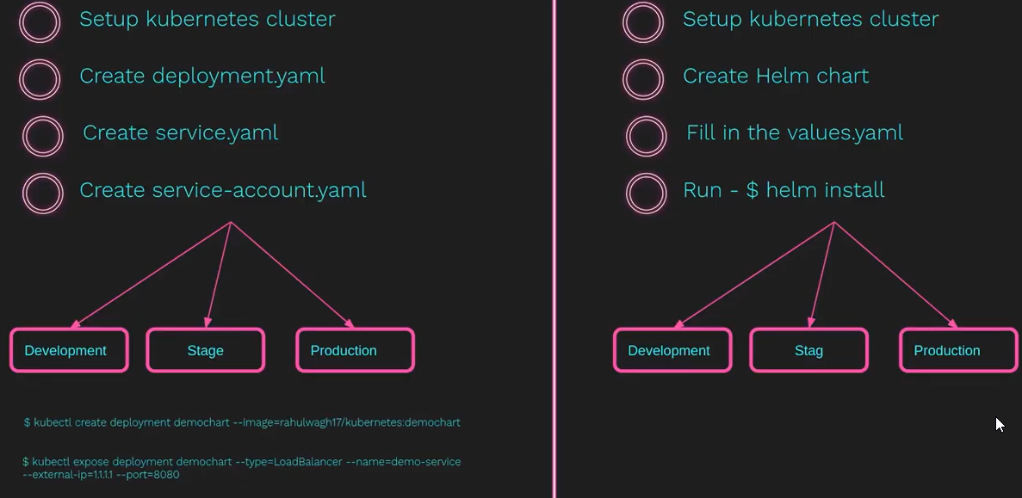

1. How I install Helm chart and prepared my first _Hello World_ chart - Part 2

Before installing the helm, we need to install the Kubernetes cluster

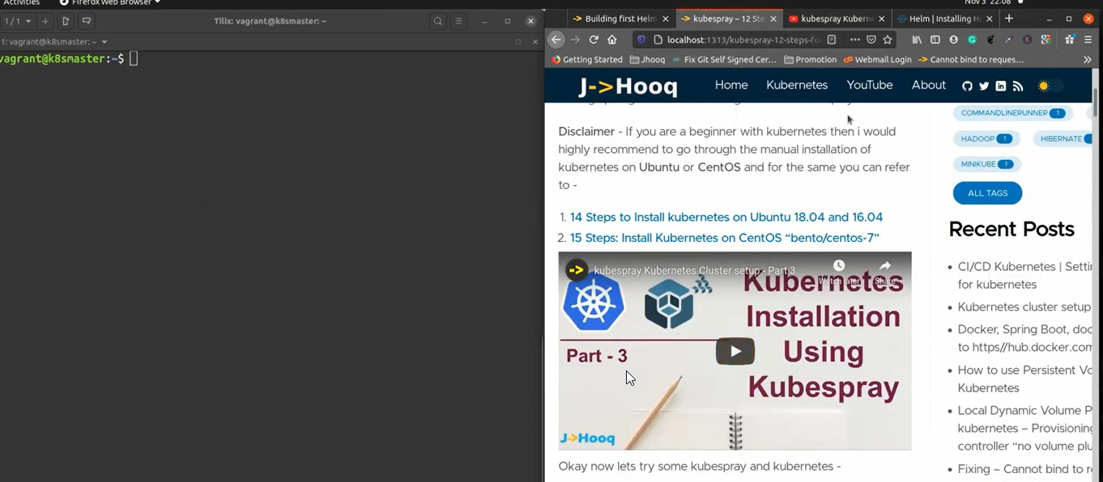

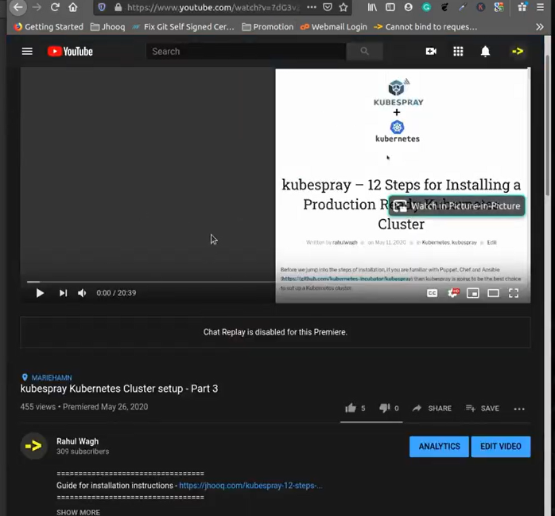

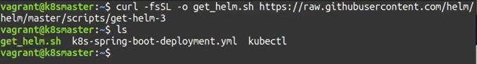

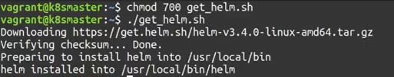

To verify it use the command helm it will list all the helm documentation and also run the helm version

To create the helm chart

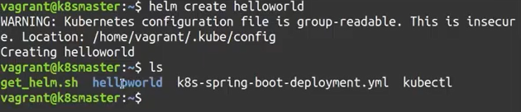

It will create the directory helloworld or run the command ls -lart | grep helloworld

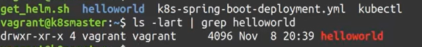

To verify the structure of helloworld

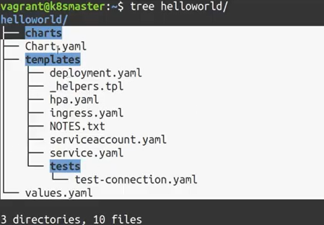

And also we need to update the some values in values.yaml ( ClusterIp to Nodeport because when ever we run the application that application needs to be exposed as a service and to expose that service we need to assign Nodeport NOT the ClusterIp) because we running the virtual environment and we need to expose as node port

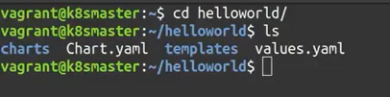

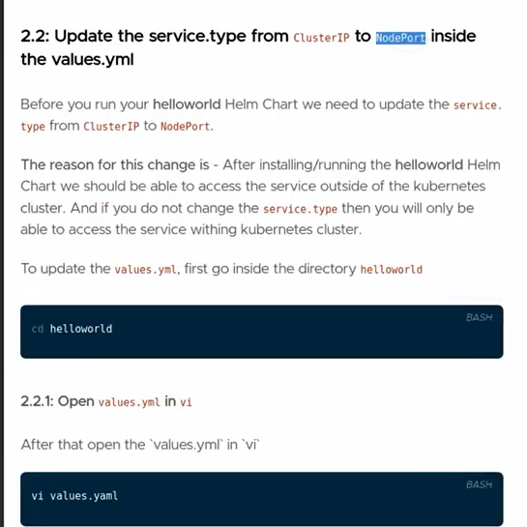

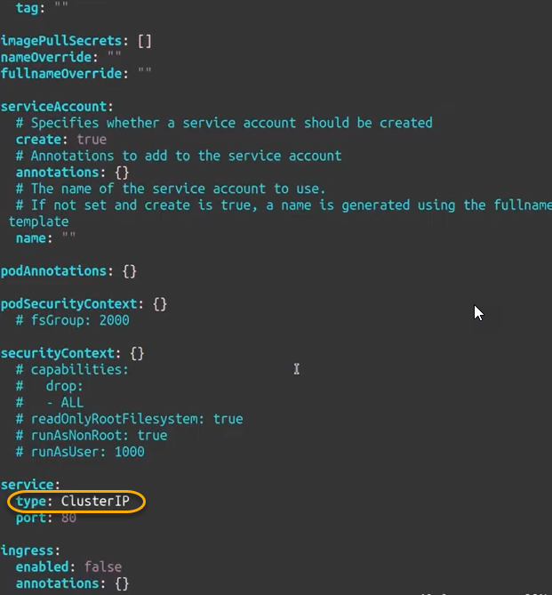

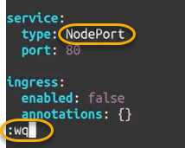

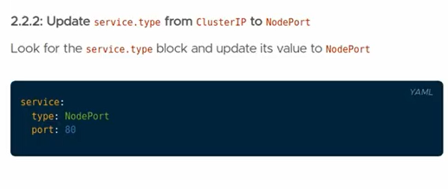

Install the helmchart using the command

Before that we need to get out this directory cd ..

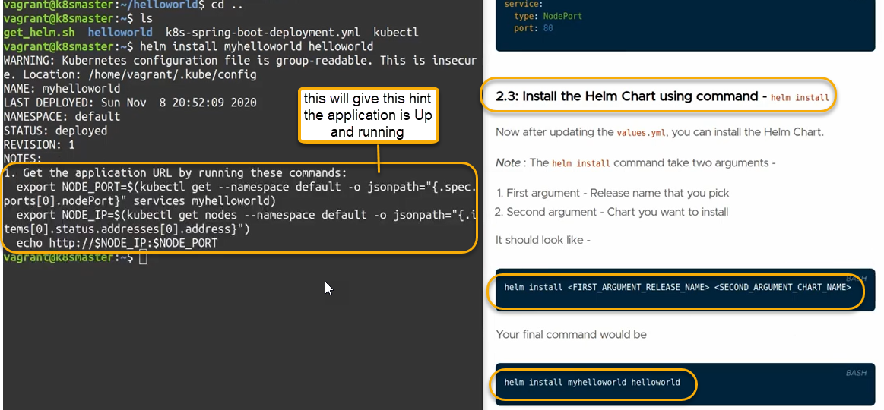

To verify if the helm install or not

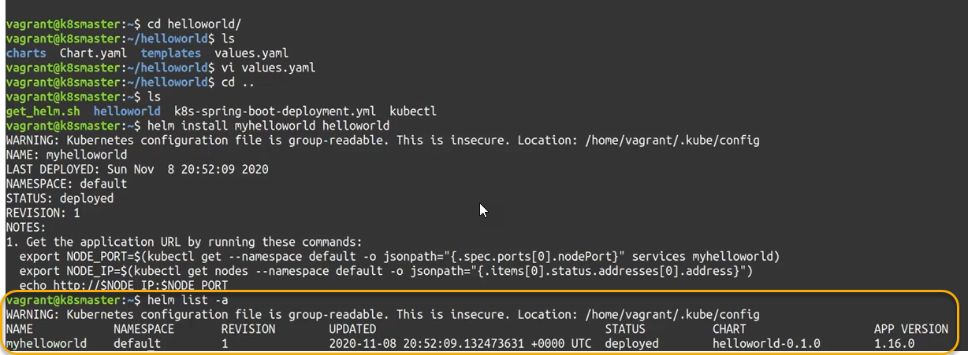

Release name is myhelloworld

How to access the application and we installed nginx server provided by helm package

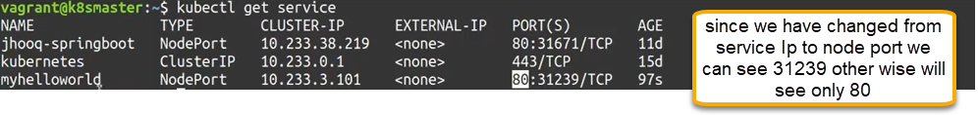

Type of Ip address of virtual machine of Kubernetes cluster running and add the 31239

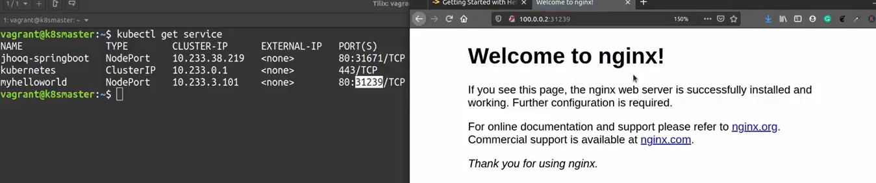

The port if we run it from our end then it will be different usually the port range will be 30000-32767

1. What are Helm Chart Repositories and how to work with it - Part 3

apt.yum.dnf are most popular package manager to install the application inside the linux which is popularly known as upstream.

Similarly helm provide you the upstream repository (which contains pre-defined helm chart which is maintained by helm chart community)

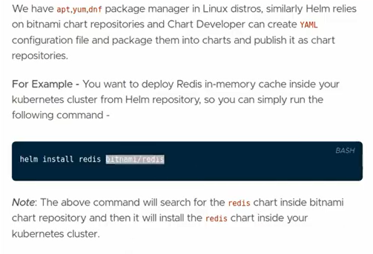

So that it will be there in redis cache

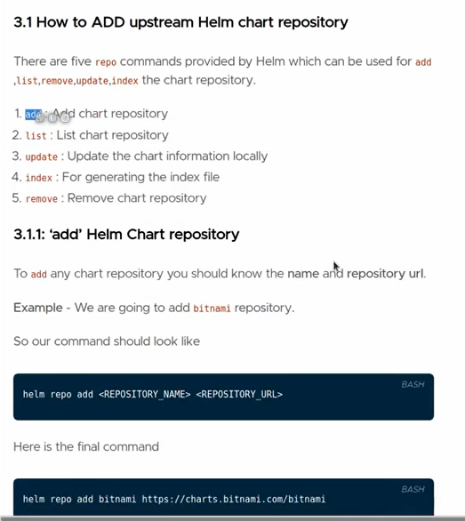

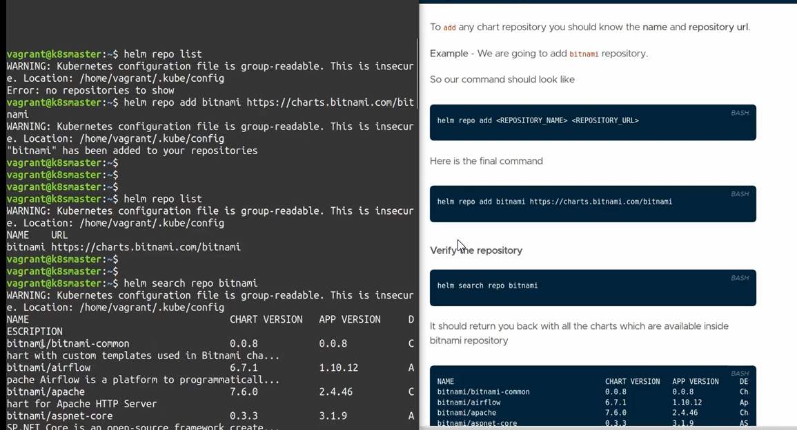

We can use any of the prebuilt helm chart into local helm chart environment

Update helm chart repository

If your continuously working helm chart environment and you need to pull fresh changes (latest changes) inside the bitnami repository

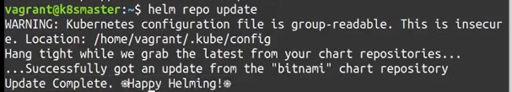

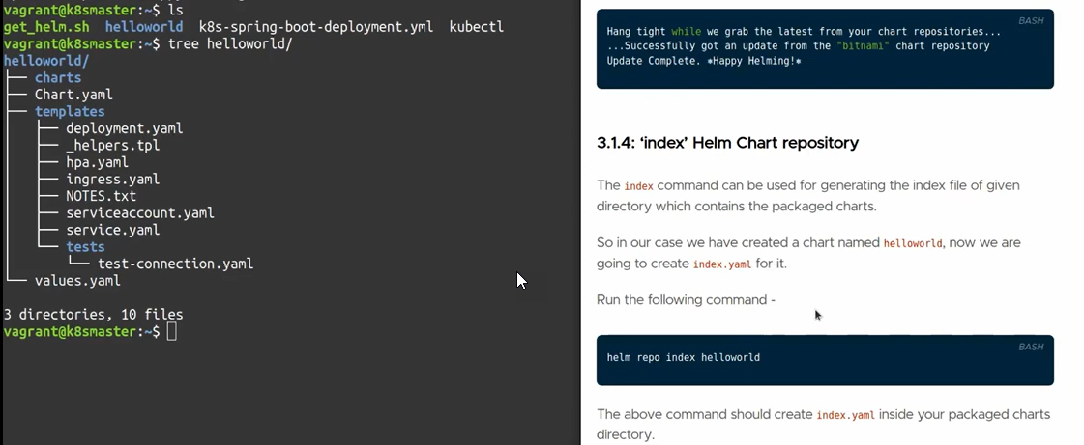

You should not be there in helm chart repository



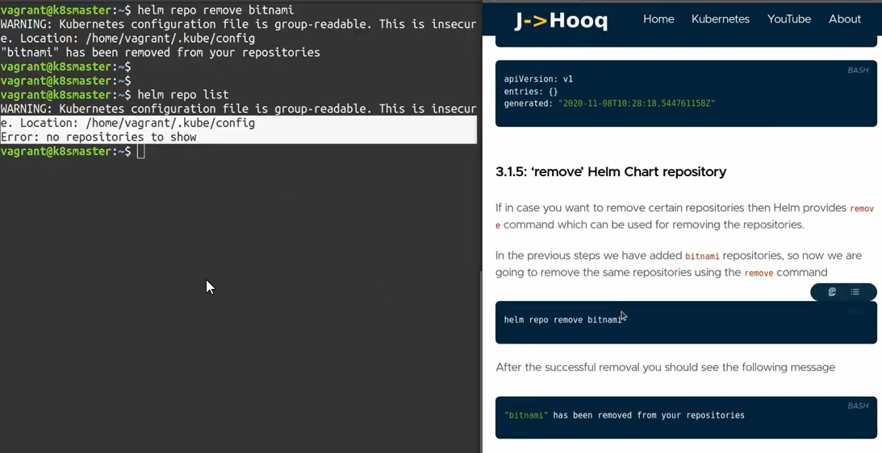

1. What is Helm Chart _Plugins_ and how to use it. - Part 4

Why we need helm chart plugin?

Helm diff is one of the plugin in helm chart

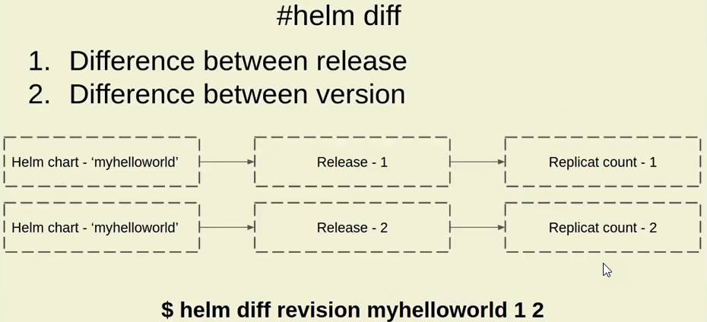

helm plugin list will show the list of plugins installed in the application

so if it is not there install it from the git repository

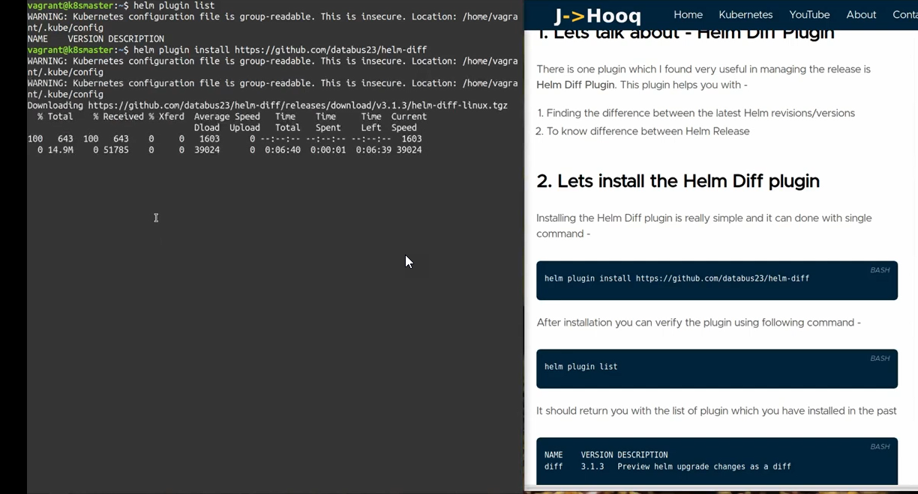

To create the release we need install the helloworld helmchart and to verify if you create the successful release or not use the command helm list -a

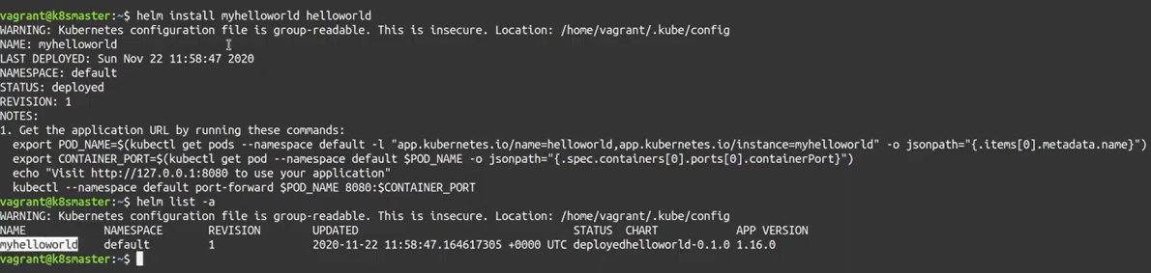

Now use the same chart create the second release but increase the replica count to ‘2”

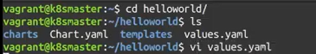

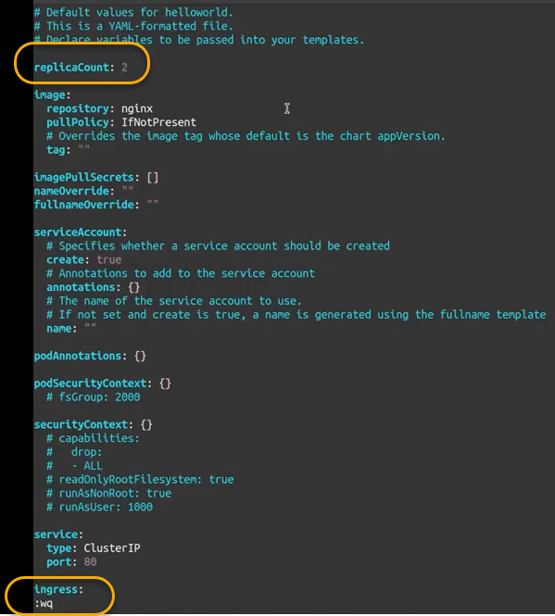

To check if the values are updated or not use the command cat values.yaml



To apply the changes, we need to use the helm upgrade

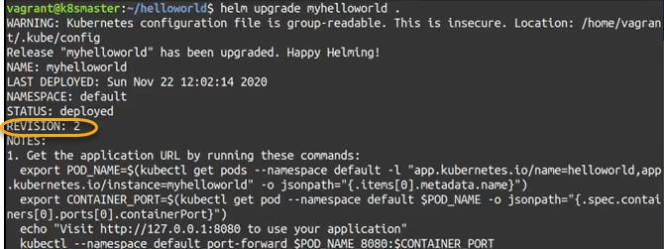

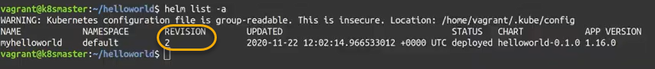

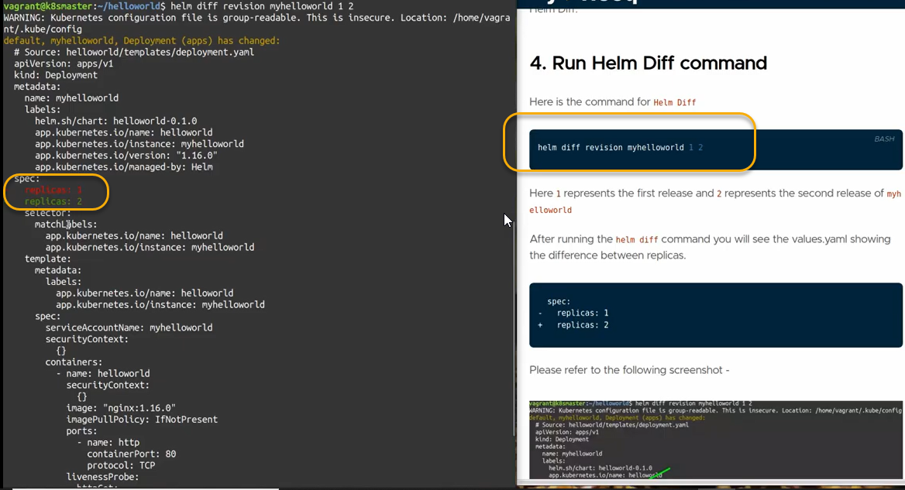

To uninstall the plugin

